1. Install python
2. Download pyserial and dji-firmware and unzip to say c:\DJI\
3. Open cmd as administrator   
   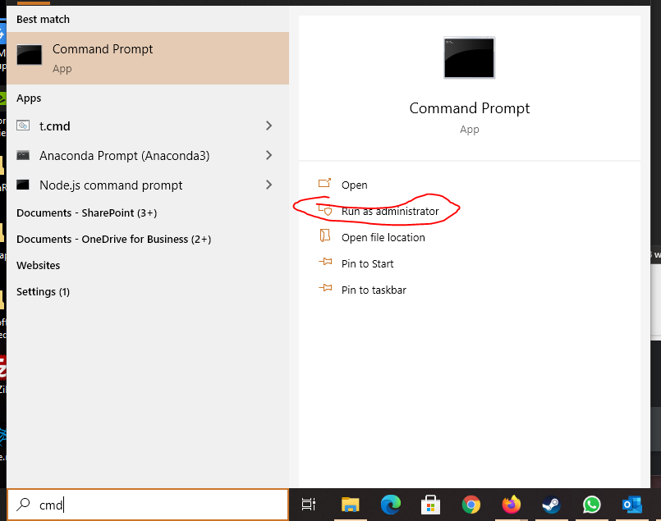
4. Install pyserial  
   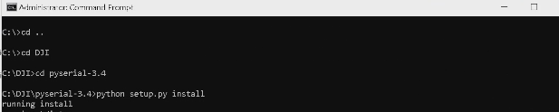
5. Connect the drone and power on. Open device manager and look for the com port, mine was in ports and COMS  
   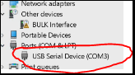 In this you can see it is com3
6. Head back into the DJI tools directory  
   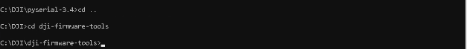
7. Run **python comm_og_service_tool.py com3 WM160 GimbalCalib JointCoarse**
8. Run **python comm_og_service_tool.py com3 SPARK GimbalCalib LinearHall**
9. **Power off drone and then hope it works ;P**